**TODO**

* ~~Need to re-create catalogue service container – doesn’t run for some reason. (Possibly because the mysql module is missing – run the container without –d to see the logs.~~
  + ~~Maybe needs mysql added as package.json and the container be recreated?~~
* Need to figure out how to run all services together and have them talk to the MySQL database (maybe see “Connect to MySQL from an application in another Docker container” at this link - <https://hub.docker.com/_/mysql/>.
* ~~Figure out why the front-end crashes – again run without –d to see the log and the issue that’s happening: (ISSUE BELOW)~~

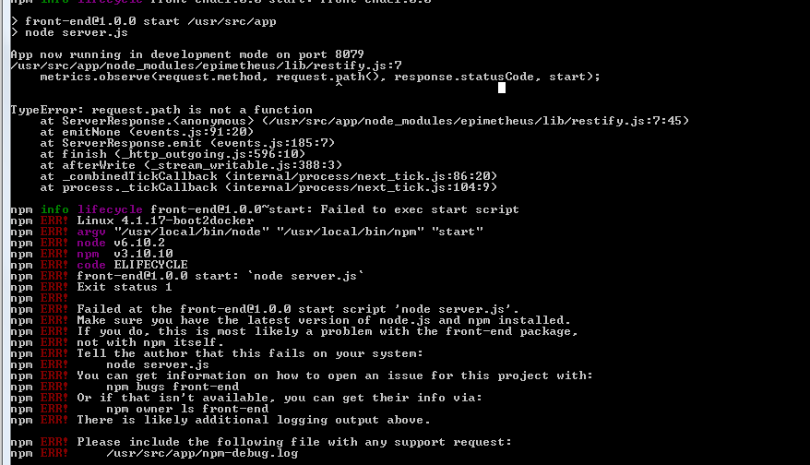

**Testing**

To get the IP you should actually be using to test the services:

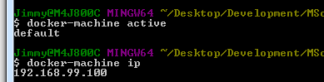

Front-end then for example would be <http://192.168.99.100:8079/>

**Services**

Ref - <https://nodejs.org/en/docs/guides/nodejs-docker-webapp/>

<https://github.com/wsargent/docker-cheat-sheet>

**User Service**

**Dockerfile**

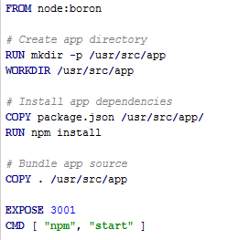

Note – had to add the following to packages.json as the app.js is not called server.js in this service:

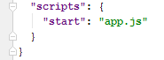

**Docker Image Creation**

Run the following command:

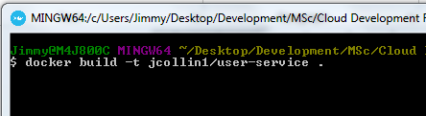

**Running the Image**

Run the following command:



CAN USE SAME PORT NUMBER AS BELOW – IGNORE ABOVE??



Test it’s running:

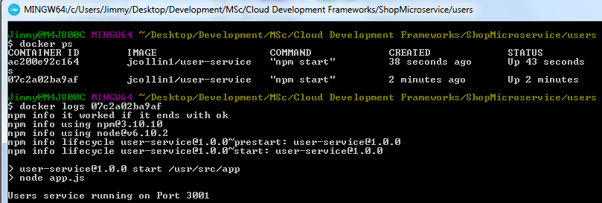

**Docker Image Deployment to DockerHub**

Ref: <https://docs.docker.com/docker-cloud/builds/push-images/>

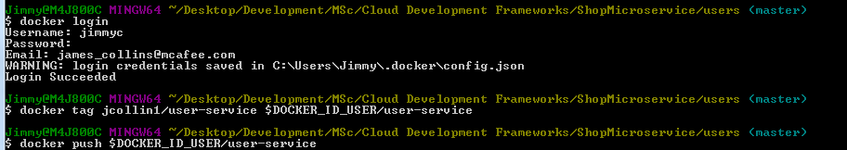

**DockerHub Link** - <https://hub.docker.com/u/jimmyc/>

Jimmyc for username

College password

**Catalogue Service**

**Dockerfile**

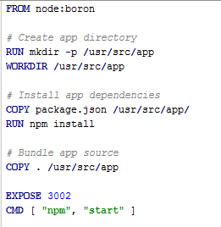

**Cart Service**

**Dockerfile**

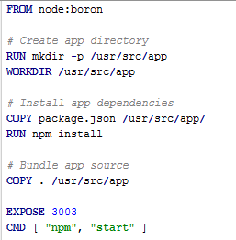

**Front-end Service**

**Dockerfile**

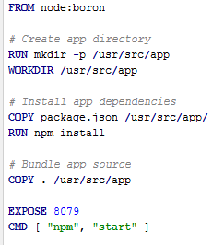

**Stock Service**

**Dockerfile**

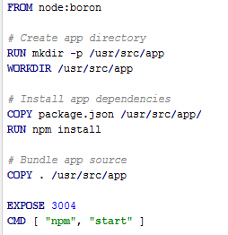

TODO – Add screen capture of common .dockerignore file.

TODO – Split doc out into Dockerfiles and common sections (creating, deploying, testing etc.)

**Database**

Ref: <https://severalnines.com/blog/mysql-docker-containers-understanding-basics>

Pull down the image from the DockerHub - <https://hub.docker.com/_/mysql/>

Start MySQL instance:



>> GENERAL

Get IP Address of Container

